GEN James D. Thurman
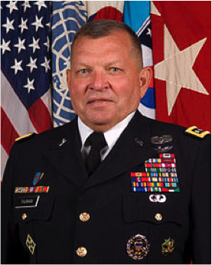

USA, Ret Former Cdr, USFK
General James D. Thurman, USA (Ret.) is the President of JD Thurman Enterprises, LLC. General Thurman is a retired U.S. Army General with over 38 years of service. General Thurman served as the Commander of United Nations Command, R.O.K – U.S. Combined Forces Command, and U.S. Forces Korea from July 2011 until October 2013. He previously served as the 18th Commanding General, U.S. Army Forces Command from June of 2010 until July 2011. Prior to that, he served as the Deputy Chief of Staff G3/5/7 Headquarters Department of the Army. He was the former Commanding General of United States Army V Corps in Heidelberg, Germany. He commanded the 4th Infantry Division from June 2004 until January 2007. During this time he deployed the Division to Iraq and assumed Command of Multi Division Baghdad, Iraq in 2006. He was also the Director of Operations for the Coalition Land Component Command for Operation Iraqi Freedom in 2003. General Thurman received a regular Army Commission from ROTC in 1975 in Armor and is a graduate of the Army War College. He is also a Senior Army Aviator. He has a B.A. in History from East Central Oklahoma University and an M.A. in Management from Webster University.

