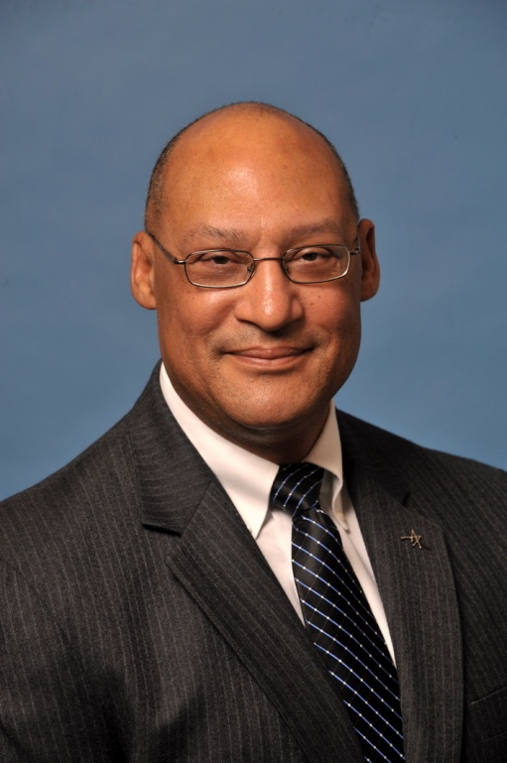

Reginald A. Grant (Reggie)

Director – Mission Success and Program Management

Reggie Grant is the Director of Mission Success and Program Management reporting to the Vice President of Program Performance supporting the Lockheed Martin Missiles and Fire Control Business Area in Dallas, Texas. In this capacity, Reggie has responsibility for establishing the Mission Success and Program Management policy and procedures for MFC, and conducting preventative and corrective reviews as required. Reggie supports the enterprise by providing executive focus on the successful execution of MFC’s programs and providing support to program management teams.

Prior to this assignment, Reggie provided executive leadership to several program departments for various Department of Defense customers interested in advancing missile, launcher and vehicle technologies. Some of these include Tactical Missile Advanced Programs, Future Intelligent Vehicles, Combat Maneuver Systems, and United Kingdom Launcher Programs. Reggie’s breadth of program and technical experience includes fire support weapons, launchers and command and control systems, robotics and combat vehicles. He has served in numerous program, business and technical positions during his career at Missiles and Fire Control.

Prior to coming to Lockheed Martin Missiles and Fire Control, Reggie spent 10 years on active duty as a fire support officer in the U.S. Army in various positions of responsibility. Reggie joined the Lockheed Martin Missiles and Fire Control team (then LTV) in 1988 as a Systems Engineer. Reggie brought his Army experience in support of several company fire support projects.

Continuing his service to country, Reggie served 17 years in the U. S. Army Reserves while working for Lockheed Martin, achieving the rank of Colonel. His last assignment was Commander, 4th Brigade (Combat Service Support), 95th Division (Institutional Training). In this position, Reggie commanded 600 soldiers across 9 Mid-Western States. He entered the Retired Reserves in August 2005.

Reggie has received numerous military and civilian awards including National Black Engineer of the Year Award Nominee for 2008, the Missiles and Fire Control Manager of the Year for 2007, the Excellence Award for the M270B1 Team in 2007 and the Department of Defense Legion of Merit in 2005.

Reggie is a 1978 graduate of the United States Military Academy at West Point, New York with a Bachelor of Science Degree in General Engineering. He also holds a Master’s Degree in Business Administration with an emphasis in Performance Management from Dallas Baptist University.

Reggie and his wife Carole, live in Arlington, Texas. They are the proud parents of three daughters; Elizabeth, Sarah and Susan.

